**MST 1102- Introduction to Statistics WkSheet 5**

**(Last Name, First Name): ______________________________________________________________**

**Data Presentation III**

1. 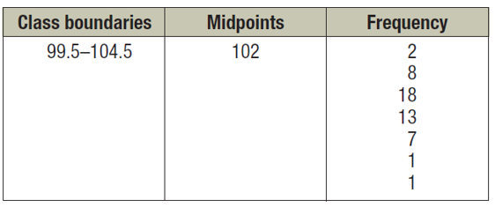The histogram below shows the record high temperature $(°F)$ for each of 50 states.

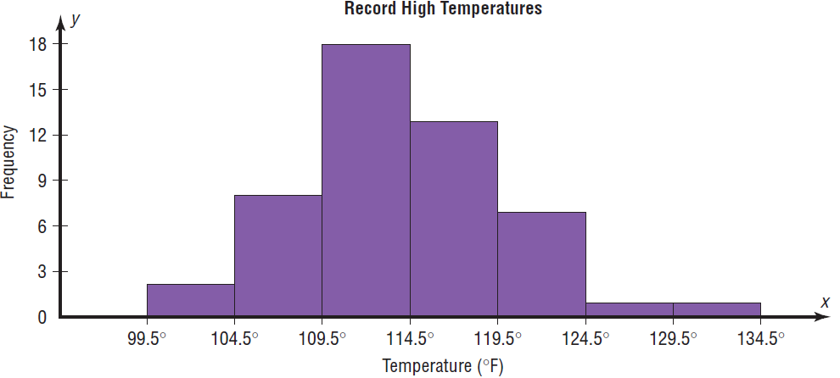

1. Use the histogram to complete the table on the right. **[2 marks]**
2. Superimpose a frequency polygon on the histogram. **[2 marks]**

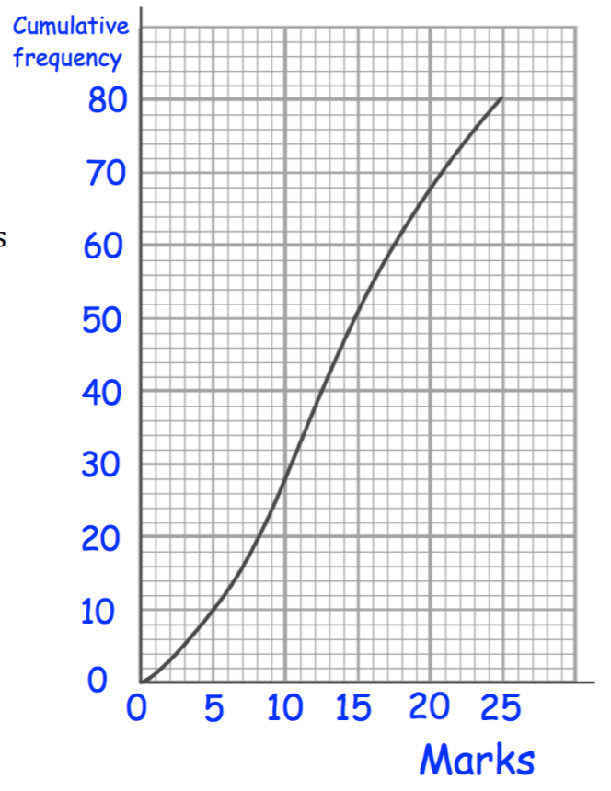

1. Some students complete a quiz. The cumulative frequency graph on the right shows their results.
2. How many students completed the quiz? ________________________ **[1 mark]**
3. 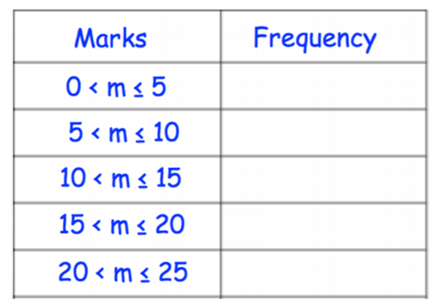Complete the frequency table below. **[2 marks]**
4. What percentage of the students scored above 20 marks? **[2 marks]**
5. Construct a stem plot for the data set which represents the ages of 50 social workers in Georgetown. **[4 marks]**

|  |  |
| --- | --- |
|  |  |
|  |  |
|  |  |
|  |  |
|  |  |
|  |  |
|  |  |
|  |  |

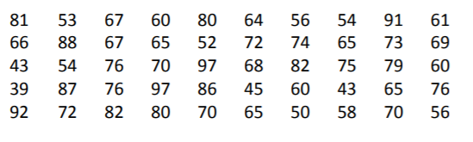

1. Consider the stem and leaf diagrams below.
2. 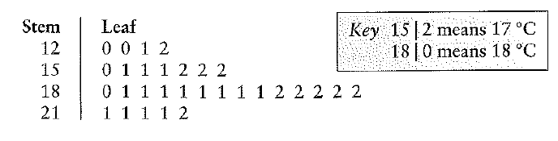Identify the values circled. **[2 marks]**
3. Identify the values circled using both keys. **[4 marks]**

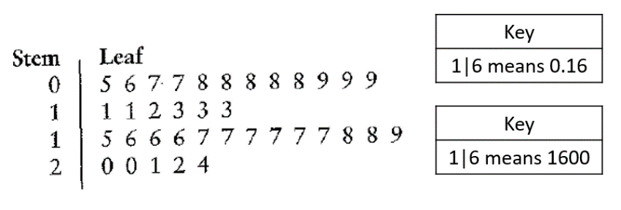

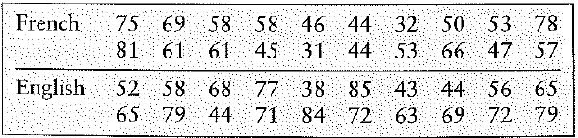

1. The data to the right above shows the French and English scores of student from a grade 11 class. Use a back to back stem and leaf diagram to compare the French and English scores. **[6 marks]**

|  |  |  |
| --- | --- | --- |
|  |  |  |
|  |  |  |
|  |  |  |
|  |  |  |
|  |  |  |
|  |  |  |
|  |  |  |
|  |  |  |

Comment:

1. The following stem-and-leaf display is prepared for the number of hours that 25 students spent working on computers during the past month. Prepare a new stem-and-leaf-display by grouping the stems. **[3 marks]**

|  |  |
| --- | --- |
|  |  |
|  |  |
|  |  |
|  |  |
|  |  |

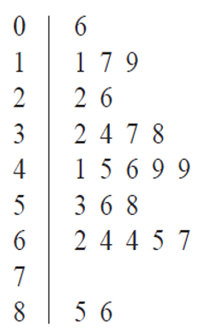

1. Determine the lower quartile, median and upper quartiles for the datasets below. **[12 marks]**
2. **3 3 5 6 8 9 12 14 19 20 24**
3. **20 23 23 26 27 28**
4. **147 150 154 158 159 162 164 165**
5. **10 12 13 15 19 19 24 26 26**
6. 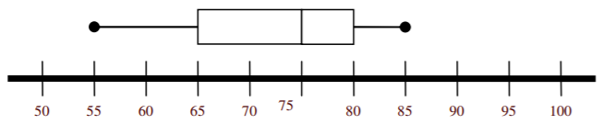Refer to the following information. Ms. Beckles grades on a curve in which the top 25% of the test scores earn A’s, the middle 50% earn C’s, and the bottom 25% earn F’s. The box and whisker plot above shows the distribution of scores on the last test.
7. The median score on the quiz is ____________________. **[1 mark]**
8. The range of scores for the persons who earned C’s is ________________________. **[1 mark]**
9. 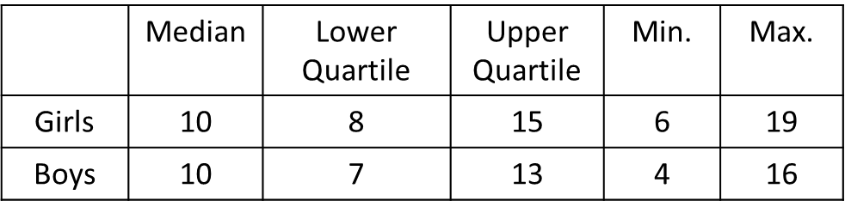A class of pupil played a computer game which tested how quickly they reacted to a visual instruction to press a particular key. The computer measured the reaction times in tenths of a second and stored a record of the sex and reaction time of each pupil. Finally it displayed the following summary statistics for the whole class as seen in the table on the right.
10. Draw comparative boxplots for the reaction times for boys and girls. **[3 marks]**



1. Write a brief comparison of the performance of boys and girls in this game. **[2 marks]**

______________________________________________________________________________________________________________________________________________________________________________________________________________________________________________________________________

1. Consider the data set below. Construct a modified boxplot for the data. **[5 marks]**



**Total: 52 marks**